

**New Dwelling Permit Application**

100 17th Avenue NW, Glenwood, MN 56334

Phone: 320-634-5433

Building Inspector Michael Friedrichs: 320-377-9029

Site Address _________________________________________________ PID # ________________________

Owner(s) _____________________________________________ Daytime Phone _______________________

Owner’s Address (if different from above) _______________________________________________________

Approximate starting date ____________________________________________________________________

Estimated total cost of project, including labor and materials $________________________________________

Licensed Contractor’s Name ____________________________________ License #_____________________

Contractor’s Phone _________________________________

Type of Construction (circle one): Build Prefabricated Modular Foundation Only

Describe in detail the work to be done _______­­­­­­­­­____________________________________________________

­­­­­­­­­­­­­­­­­­­__________________________________________________________________________________________

Building covering materials, if applicable ________________________________________________________

Dimension of uses in square feet: Dwelling (first floor) __________ Basement ________ Finished? Yes/No

Dwelling (additional stories) ________ Garage ________

Plumbing Contractor__________________________________________ Phone ________________________

Mason and Concrete Contractor ________________________________ Phone ________________________

Heating and Venting Contractor ________________________________ Phone ________________________

Air Exchanger? Yes ________ No ________

**Required Forms and Items to Return With Application:**

1. **Site Plan**
2. **Full size set of Construction Plans with cross-sections**
3. **One small set of Construction Plans (8 ½ x 11) for file**
4. **Heat/Loss Calculations**
5. **Signed Property Disclaimer**

**If property owner is acting as his/her own general contractor, property owner must sign the Licensed Contractor Disclaimer**

**Utilities Disclaimer**

1. Will you be connecting to Municipal Water? ______________
2. Will you be connecting to Municipal Sewer? ______________
3. Will you be connecting to Municipal Storm Sewer?______________
4. Will you be excavating in the City right-of-way? ______________
5. What is the intended use for the application?
   * Residential __________
   * Commercial _____________
   * Industrial ____________
6. Will on acre or more of land be disturbed? ____________
   * If so, a storm water permit must be applied for with the Minnesota Pollution Control Agency. A copy of the MPCA permit must be attached to this form.
7. Is this new construction? _____________
8. Is this an addition to an existing structure? ___________
9. Is this a relocation of an existing structure? ____________

I hereby certify that I have read and examined this application and know the same to be true and correct. All provisions of laws and Ordinances governing this type of work will be complied with, whether specified herein or not. The granting of this permit does not presume to give authority to violate or cancel all the provisions of any other State or local laws regulating construction.

**I have identified all property boundaries, easements, flood zones,**

**and/or wetlands existing on the property on my site plan and application.**

The undersigned further agrees the City of Glenwood and its administrative staff relied on the accurateness of this application, plans, and specification relative to this project and holds the City of Glenwood and its employees harmless from all liability arising from the granting of this permit.

**Signature of Owner or Contractor** ____________________________________________________________

**Zoning Administrator** ______________________________________________________________________

**Public Works Director** ______________________________________________________________________

**Building Official** ___________________________________________________________________________

**This Permit Expires One Year From:** ___________________________

|  |  |  |
| --- | --- | --- |
| For Office Use Only | | |
| Permit #: | Permit Fee: | Water Hook- Up Fee: |
| PID#: | Surcharge: | Sewer Hook-Up Fee: |
| Date Rec’d: | Plan Check: | Water Meter: |
|  |  | Total Fee: |

Notice To All Applicants

A site plan is required with all applications. The site plan should include at minimum:

* Lot Dimensions
* All existing uses and structures within 100 feet of the subject property
* All adjacent streets and alleys
* The dimensions of the proposed footprint of the building with ALL setbacks noted (setbacks include; distance from the property lines, streets and alleys, adjacent structures, ordinary high-water mark, etc. and the structure.)
* All setback requirements are measured to the overhang or outer edge of gutters, not the foundation or sidewall of the building
* Height of side wall, measured from the finished floor elevation to the point at which the sidewall top plate adjoins the rafter
* Height of peek, measured from the finished floor elevation to the top of the peak
* Proposed drainage of storm water run-off away from the proposed structure
* Proposed finished floor elevation of structure

Plans do not need to be professionally drawn but should include all of the information requested. The following sample site plan shows the minimum detail expected so the permit process can proceed smoothly.

**Setback requirements are listed on the next page***

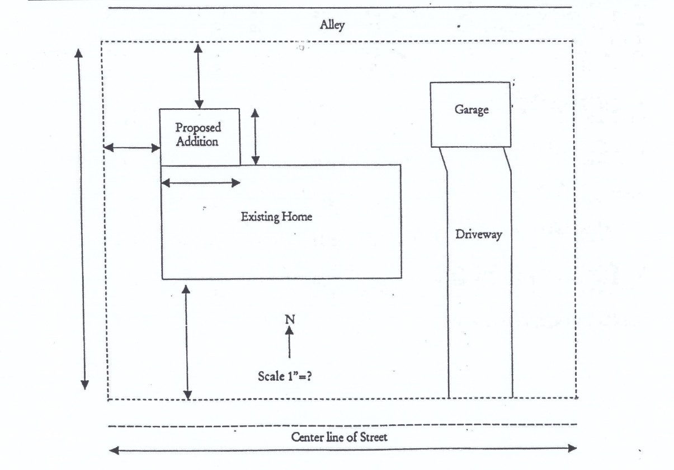

Lot, Yard and Density Requirements

